目 錄

0 前言 5

0.1 jQuery簡介 5

0.2 網頁應用程式開發基礎知識複習 6

0.2.1 DOM導論 6

0.2.2 CSS導論 6

0.2.2.1 CSS樣式表規則 6

0.2.2.2 CSS樣式表使用方法 7

0.2.3 HTTP Request Message 與Response Message之格式 7

0.2.3.1 HTTP Request Message 7

0.2.3.2 Response Message 7

0.2.4 表單資料(Form Data)進行URL encoding (Percent-encoding)的規則 8

1 樣式控制I 9

1.1 CSS 樣式修改—基本方法 9

1.1.1 常用的「jQuery函式」相關API 9

1.1.1.1 jQuery() 9

1.1.2 常用的「元素樣式」相關API 9

1.1.2.1 jQuery物件.css() 9

1.1.3 範例程式：T01.html(第一頁) 10

1.2 CSS 樣式修改—使用累進值 12

1.2.1 常用的「元素樣式」相關API 12

1.2.1.1 jQuery物件.css(相對的屬性值) 12

1.2.2 範例程式：T01.html(第二頁) 12

1.3 CSS 樣式修改—使用「簡單物件(Plain Object)」 14

1.3.1 常用的「元素樣式」相關API 14

1.3.1.1 jQuery物件.css(簡單物件) 14

1.3.2 範例程式：T01.html(第三頁) 14

2 選擇器I 16

2.1 基礎(Basic) 16

2.1.1 選擇器摘要 16

2.1.2 範例程式：T02.html(Part I) 16

2.2 表單(Form) 18

2.2.1 選擇器摘要 18

2.2.2 範例程式：T02.html(Part II) 18

2.3 基本過濾器(Basic Filter) 20

2.3.1 選擇器摘要 20

2.3.2 常用的「表單事件」相關API 20

2.3.2.1 jQuery物件.focus() 20

2.3.3 範例程式：T02.html(Part III) 20

3 選擇器 II 22

3.1 孩子過濾器(Child filter) 22

3.1.1 選擇器摘要 22

3.1.2 範例程式：T03.html(Part I) 22

3.2 內容過濾器(Content filter) 24

3.2.1 選擇器摘要 24

3.2.2 範例程式：T03.html(Part II) 24

3.3 其他 26

3.3.1 選擇器摘要 26

3.3.2 範例程式：T03.html(Part III) 26

4 樣式控制 II 28

4.1 使用HTML元素之「類別(Class)」屬性 28

4.1.1 常用的「元素樣式」相關API 28

4.1.1.1 jQuery物件.addClass() 28

4.1.1.2 jQuery物件.removeClass() 28

4.1.2 範例程式：T04.html(第一頁) 28

4.2 判斷HTML元素之「類別(Class)」屬性 31

4.2.1 常用的「元素樣式」相關API 31

4.2.1.1 jQuery物件.hasClass() 31

4.2.2 常用的「特效與動畫」相關API 31

4.2.2.1 jQuery物件.hide() 31

4.2.2.2 jQuery物件.show() 31

4.2.2.3 jQuery物件.slideDown() 32

4.2.2.4 jQuery物件.slideUp() 32

4.2.2.5 jQuery物件.slideToggle() 32

4.2.2.6 jQuery物件.fadeIn() 33

4.2.2.7 jQuery物件.fadeOut() 33

4.2.2.8 jQuery物件.fadeToggle() 33

4.2.3 常用的「DOM元素的操作」相關API 34

4.2.3.1 jQuery物件.next() 34

4.2.3.2 jQuery物件.prev() 34

4.2.4 CSS選擇器的優先順序 34

4.2.5 範例程式：T04.html(第二頁) 36

5 事件處理—滑鼠事件 39

5.1 jQuery支援的常用滑鼠事件 39

5.2 Click事件使用範例 40

5.2.1 常用的「滑鼠事件」相關API 40

5.2.1.1 jQuery物件.click() 40

5.2.2 常用的「表單輸入」相關API 40

5.2.2.1 jQuery物件.val() 40

5.2.3 範例程式：T05.html(第一頁) 40

5.3 Dblclick事件使用範例 42

5.3.1 常用的「滑鼠事件」相關API 42

5.3.1.1 jQuery物件.dblclick() 42

5.3.2 常用的「元素屬性值」相關API 42

5.3.2.1 jQuery物件.attr() 42

5.3.2.1 jQuery物件.prop() 43

5.3.3 常用的「特效與動畫」相關API 43

5.3.3.1 jQuery物件.animate() 43

5.3.4 範例程式：T05.html(第二頁) 44

5.4 Hover事件使用範例 47

5.4.1 常用的「滑鼠事件」相關API 47

5.4.1.1 jQuery物件.hover() 47

5.4.2 常用的「特效與動畫」相關API 47

5.4.2.1 jQuery物件.stop() 47

5.4.3 範例程式：T05.html(第三頁) 47

6 事件處理—表單事件 50

6.1 jQuery支援的常用表單事件 50

6.2 Submit、Blur事件使用範例 51

6.2.1 常用的「表單事件」相關API 51

6.2.1.1 jQuery物件.submit() 51

6.2.1.2 jQuery物件.blur() 51

6.2.1.3 jQuery物件.focus() 51

6.2.2 常用的「工具函式」相關API 51

6.2.2.1 jQuery物件.each() 51

6.2.2.2 jQuery物件.position() 51

6.2.3 常用的「DOM元素的操作」相關API 52

6.2.3.1 jQuery物件.append() 附加么子 52

6.2.3.2 jQuery物件.prepend() 附加長子 52

6.2.3.3 jQuery物件.after() 使…在後 52

6.2.3.4 jQuery物件.before() 使…在前 53

6.2.3.5 jQuery物件.insertAfter() 54

6.2.3.6 jQuery物件.insertBefore() 55

6.2.3.7 jQuery物件.remove() 56

6.2.4 Client/Server範例程式 56

6.2.4.1 用戶端範例程式T06.html(第一頁) 56

6.2.4.2 伺服端範例程式 processLogin.aspx 59

6.3 Change事件使用範例 62

6.3.1 常用的「表單事件」相關API 62

6.3.1.1 jQuery物件.change() 62

6.3.2 常用的「元素內容」相關API 62

6.3.2.1 jQuery物件.html() 62

6.3.2.2 jQuery物件.text() 62

6.3.3 範例程式：T06.html(第二頁) 62

7 註冊「事件監聽器」的進階方法 65

7.1 將一個「事件監聽器」綁定至多個事件 65

7.1.1 常用的「事件」相關API 65

7.1.1.1 jQuery物件.on() 65

7.1.2 常用的「工具函式」相關API 65

7.1.2.1 jQuery.each() 65

7.1.3 範例程式：T07.html(第一頁) 66

7.2 將一個「事件監聽器」從多個事件解綁 67

7.2.1 常用的「事件」相關API 67

7.2.1.1 jQuery物件.off() 67

7.2.2 範例程式：T07.html(第二頁) 68

7.3 將一個「事件監聽器」一次性地綁定至多個事件 69

7.3.1 常用的「事件」相關API 69

7.3.1.1 jQuery物件.one() 69

7.3.2 範例程式：T07.html(第二頁) 69

8 jQuery UI 71

8.1 jQuery UI 介紹 71

8.2 Datepicker 71

8.2.1 使用要點 71

8.2.2 使用範例：T08.html 72

8.2.2.1 樣式表 72

8.2.2.2 JavaScript 73

8.2.2.3 HTML 73

8.3 Accordion 74

8.3.1 使用要點 74

8.3.2 使用範例：T08.html 74

8.3.2.1 樣式表 74

8.3.2.2 JavaScript 74

8.3.2.3 HTML 75

8.4 Autocomplete 76

8.4.1 使用要點 76

8.4.2 使用範例：T08.html 76

8.4.2.1 樣式表 76

8.4.2.2 JavaScript 76

8.4.2.3 HTML 76

8.5 Dialog 77

8.5.1 使用要點 77

8.5.2 使用範例：T08.html 77

8.5.2.1 樣式表 78

8.5.2.2 JavaScript 78

8.5.2.3 HTML 79

8.6 Draggable 80

8.6.1 使用要點 80

8.6.2 使用範例：T08.html 80

8.6.2.1 樣式表 80

8.6.2.2 JavaScript 80

8.6.2.3 HTML 81

8.7 Droppable 81

8.7.1 使用要點 81

8.7.2 使用範例：T08.html 81

8.8 Tooltip 81

8.8.1 使用要點 81

8.8.2 常用的「工具函式」相關API 82

8.8.2.1 jQuery.is() 82

8.8.3 使用範例：T08.html 82

8.8.3.1 樣式表 83

8.8.3.2 JavaScript 83

8.8.3.3 HTML 84

8.9 Spinner 84

8.9.1 使用要點 84

8.9.2 使用範例：T08.html 84

8.9.2.1 樣式表 85

8.9.2.2 JavaScript 85

8.9.2.3 HTML 85

8.10 Tabs 85

8.10.1 使用要點 85

8.10.2 使用範例：T01.html 85

8.10.2.1 樣式表 86

8.10.2.2 JavaScript 86

8.10.2.3 HTML 86

# 前言

## jQuery簡介

* jQuery是一套跨瀏覽器的JavaScript函式庫(Function Library)，強化了HTML與JavaScript之間的操作，是目前最受歡迎的JavaScript函式庫。
* 依據W3Techs於2023年1月對全球人氣排名前一千萬大網站所作的統計報告：
* 最多網站所使用的用戶端(Client-Side)程式語言：

|  |  |  |
| --- | --- | --- |
| 程式語言 | | 使用率 |
| 1. | [JavaScript](https://w3techs.com/technologies/details/cp-javascript/all/all) | 98.3% |
| 2. | [Flash](https://w3techs.com/technologies/details/cp-flash/all/all) | 1.5% |

* 最多網站所使用的JavaScript函式庫：

|  |  |  |  |
| --- | --- | --- | --- |
| JavaScript函式庫 | | 使用率 | 市佔率 |
| 1. | jQuery | 77.6% | 94.3% |
| 2. | Bootstrap | 21.3% | 25.9% |
| 3. | Modernizr | 9.2% | 11.2% |

* jQuery的第一個版本是由John Resig在2006年1月的BarCamp NYC上所釋出的。 目前則由成立於2009年9月份的 「The jQuery Project」 (http://jquery.com/) 繼續研發，不定期推出更新版本。

## 網頁應用程式開發基礎知識複習

### DOM導論

* DOM(Document Object Model/文件物件模型)是一個表達、存取網頁中物件的介面(API/Application Programming Interface)。
* DOM是全球資訊網協會(World Wide Web Consortium，W3C)所制定的一套標準，大部分的瀏覽器開發廠商都會遵循並採用這套標準。
* 有了DOM， JavaScript就可以和網頁上的HTML進行互動，並修改HTML內容。
* DOM將一個HTML網頁的資料結構以樹狀(tree)圖來表達，樹狀圖中的每一塊狀項目稱為節點(nodes)。
* HTML DOM樹狀圖範例

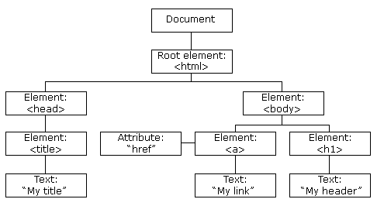

|  |
| --- |
| <html>  <head>  <title>My title</title>  </head>  <body>  <a href="t1.html">My link</a>  <h1>My header</h1>  </body>  </html> |

### CSS導論

* CSS(Cascading Style Sheet/串接樣式表/層疊樣式表)，是一種用於控制網頁樣式並允許樣式資訊與網頁內容分離的標記性語言。
* W3C於1996年審核通過CSS規格(CSS Level 1)。它以HTML為基礎，提供了豐富的格式化功能。目前W3C公告的最新建議規格為CSS Level 3 (2011年)。

#### CSS樣式表規則

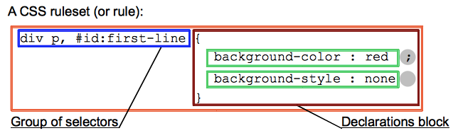

#### CSS樣式表使用方法

* 行內樣式表(In-line Style Sheets)

<h1 style="color:Red;font-size:2cm;">Hello Kitty</h1>

* 內嵌式樣式表(Embedded Style Sheets)

<style type="text/css">

h2 {color:Blue; font-size:2cm;}

</style>

* 外部連結式樣式表(External Style Sheets)

<link rel="Stylesheet" type="text/css" href="myStyle.css" />

### HTTP Request Message 與Response Message之格式

#### HTTP Request Message

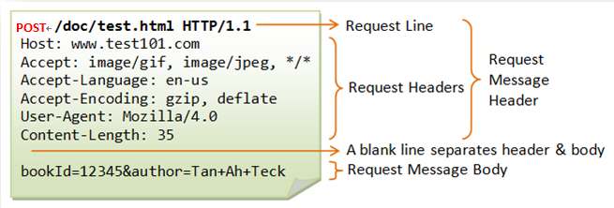

Request-Line = Method Request-URI HTTP-Version

#### Response Message

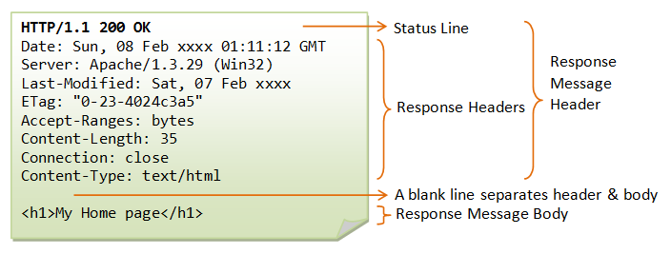

Status-Line = HTTP-Version Status-Code Reason-Phrase

### 表單資料(Form Data)進行URL encoding (Percent-encoding)的規則

* The alphanumeric characters "a" through "z", "A" through "Z" and "0" through "9" remain the same.
* The special characters ".", "*", "_", and "-" remain the same.
* The space character " " is converted into a plus sign "+". (註: %20亦可)
* All other characters are unsafe and are first converted into one or more bytes using some encoding scheme. Then each byte is represented by the 3-character string "%xy", where xy is the two-digit hexadecimal representation of the byte.
* 例如：

<input type='text' name='username' value='小甜甜 A9.*_-' />

經過URL encoding (字元編碼：utf-8)之後產生之表單資料如下：

username=%E5%B0%8F%E7%94%9C%E7%94%9C+A9.*_-

# 樣式控制I

## CSS 樣式修改—基本方法

### 常用的「jQuery函式」相關API

#### jQuery()

**jQuery( selector [, context ] )**

* Accepts a string containing a CSS selector which is then used to match a set of elements.
* Parameters:
  + - selector
      * Type: Selector
      * A string containing a selector expression
    - context
      * Type: Element or jQuery or Selector
      * A DOM Element, Document, jQuery or selector to use as context
* Returns: jQuery
* 使用範例

$( "div.foo" )

**jQuery( html )**

* Creates DOM elements on the fly from the provided string of raw HTML.
* Parameters:
  + - html
      * Type: htmlString
      * A string of HTML to create on the fly. Note that this parses HTML, not XML.
* Returns: jQuery
* 使用範例

$( "<a href='https://jquery.com'></a>" )

**jQuery( callback )**

* Binds a function to be executed when the DOM has finished loading.
* Parameters:
  + - callback
      * Type: Function()
      * The function to execute when the DOM is ready.
* Returns: jQuery
* 使用範例

$(function() {

// Document is ready

});

### 常用的「元素樣式」相關API

#### jQuery物件.css()

**.css( propertyName )**

* Get the computed style properties for the first element in the set of matched elements.
* Parameters:
  + - propertyName
      * Type: String
      * A CSS property.
* Returns: String

**.css( propertyName, value )**

* Set one or more CSS properties for the set of matched elements.
* Parameters:
  + - propertyName
      * Type: String
      * A CSS property name.
    - value
      * Type: String or Number (When a number is passed as the value, jQuery will convert it to a string and add px to the end of that string.)
      * A value to set for the property.
* Returns: jQuery

### 範例程式：T01.html(第一頁)

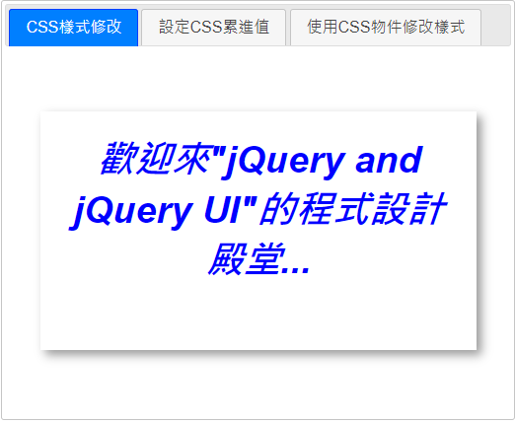

<!DOCTYPE html>

<html>

<head>

<meta charset="utf-8" />

<title>樣式控制 1</title>

<link rel="icon" href="./favicon.ico" />

<style type="text/css">

.main-box {

margin: 50px auto;

width: 400px;

height: 200px;

padding: 20px;

box-shadow: 5px 5px 10px #999;

border: 1px solid #fff;

text-align: center;

}

</style>

<link href="stylesheets/jquery-ui/base/jquery-ui.min.css" rel="stylesheet" />

<script src="javascripts/jquery-3.6.1.min.js"></script>

<script src="javascripts/jquery-ui.min.js"></script>

<script type="text/javascript">

$(function () {

$("#tabs").tabs();

$("#p1 #div1").hover(

function () { $(this).css('font-style', 'italic').css('color', 'blue')

.css('font-size', '1cm').css('font-weight', 'bold'); },

function () { $(this).css('font-style', '').css('color', '').css('font-size', '')

.css('font-weight', ''); }

);

(略)

});

</script>

</head>

<body>

<div id="tabs">

<ul>

<li><a href="#p1">CSS樣式修改</a></li>

<li><a href="#p2">設定CSS累進值</a></li>

<li><a href="#p3">使用CSS物件修改樣式</a></li>

</ul>

<div id="p1">

<div class="main-box">

<div id="div1">

歡迎來&quot;jQuery and jQuery UI&quot;的程式設計殿堂...

</div>

</div>

</div>

(略)

</div>

</body>

</html>

## CSS 樣式修改—使用累進值

### 常用的「元素樣式」相關API

#### jQuery物件.css(相對的屬性值)

**.css( propertyName, value )**

* Set one or more CSS properties for the set of matched elements.
* As of jQuery 1.6, .css() accepts relative values.
* Relative values are a string starting with += or -= to increment or decrement the current value.
* For example, if an element's padding-left was 10px, .css( "padding-left", "+=15" ) would result in a total padding-left of 25px.

### 範例程式：T01.html(第二頁)

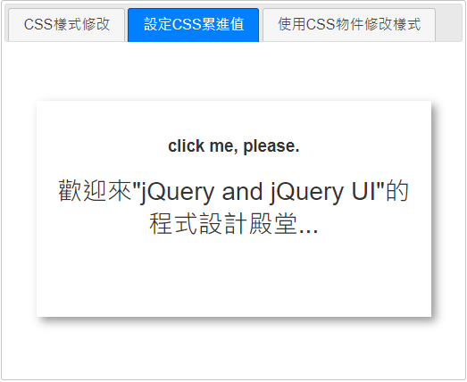

<!DOCTYPE html>

<html>

<head>

<title>樣式控制 1</title>

(略)

<script type="text/javascript">

$(function () {

$("#tabs").tabs();

(略)

$("#p2 h3").click(

function () {

$("#p2 #div2").css("font-size","+=2");

}

);

(略)

});

</script>

</head>

<body>

<div id="tabs">

<ul>

<li><a href="#p1">CSS樣式修改</a></li>

<li><a href="#p2">設定CSS累進值</a></li>

<li><a href="#p3">使用CSS物件修改樣式</a></li>

</ul>

(略)

<div id="p2">

<div class="main-box">

<h3>click me, please.</h3>

<div id="div2">

歡迎來&quot;jQuery and jQuery UI&quot;的程式設計殿堂...

</div>

</div>

</div>

(略)

</div>

</body>

</html>

## CSS 樣式修改—使用「簡單物件(Plain Object)」

### 常用的「元素樣式」相關API

#### jQuery物件.css(簡單物件)

**.css( properties )**

* Set one or more CSS properties for the set of matched elements.
* Parameters:
  + - properties
      * Type: PlainObject
      * An object of property-value pairs to set.
* Returns: jQuery

### 範例程式：T01.html(第三頁)

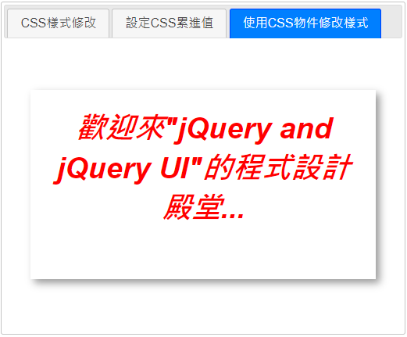

<!DOCTYPE html>

<html>

<head>

(略)

<script type="text/javascript">

$(function () {

$("#tabs").tabs();

(略)

$("#p3 #div3").hover(

function () {

$(this).css({

'font-style': 'italic', 'color': 'red',

'font-size': '1cm', 'font-weight': 'bold'

});

},

function () {

$(this).css({

'font-style': '', 'color': '',

'font-size': '', 'font-weight': ''

});

}

);

});

</script>

</head>

<body>

<div id="tabs">

<ul>

<li><a href="#p1">CSS樣式修改</a></li>

<li><a href="#p2">設定CSS累進值</a></li>

<li><a href="#p3">使用CSS物件修改樣式</a></li>

</ul>

(略)

<div id="p3">

<div class="main-box">

<div id="div3">

歡迎來&quot;jQuery and jQuery UI&quot;的程式設計殿堂...

</div>

</div>

</div>

</div>

</body>

</html>

# 選擇器I

## 基礎(Basic)

### 選擇器摘要

|  |  |  |
| --- | --- | --- |
| 選擇器 | 範例 | 說明 |
| * | $("*") | All elements |
| #*id* | $("#lastname") | The element with id="lastname" |
| .*class* | $(".intro") | All elements with class="intro" |
| .*class,*.*class* | $(".intro,.demo") | All elements with the class "intro" or "demo" |
| *element* | $("p") | All <p> elements |
| *el1*,*el2*,*el3* | $("h1,div,p") | All <h1>, <div> and <p> elements |

### 範例程式：T02.html(Part I)

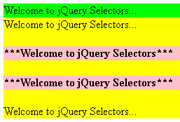

<!DOCTYPE html>

<html>

<head>

<meta charset="utf-8" />

<title>選擇器</title>

<script src="javascripts/jquery-3.6.1.min.js"></script>

<script>

$(function () {

$("div.c1").css({ backgroundColor: 'yellow' });

$("#c1-1").css({ backgroundColor: 'lime' });

$(".c1 h3, .c1 h4").css({ backgroundColor: 'pink' });

});

</script>

</head>

<body>

<div class="c1">

<div id="c1-1">Welcome to jQuery Selectors</div>

<div>Welcome to jQuery Selectors</div>

<h4>***Welcome to jQuery Selectors***</h4>

<h4>***Welcome to jQuery Selectors***</h4>

<div>Welcome to jQuery Selectors...</div>

</div>

</body>

</html>

## 表單(Form)

### 選擇器摘要

|  |  |  |
| --- | --- | --- |
| 選擇器 | 範例 | 說明 |
| :input *  (*表示jQuery自訂) | $(":input") | All input elements  (含<select>、<textarea>) |
| :text * | $(":text") | All input elements with type="text" |
| :password * | $(":password") | All input elements with type="password" |
| :radio * | $(":radio") | All input elements with type="radio" |
| :checkbox * | $(":checkbox") | All input elements with type="checkbox" |
| :submit * | $(":submit") | All input elements with type="submit"  或 <button type='submit'></button> |
| :reset * | $(":reset") | All input elements with type="reset"  或 <button type='reset'></button> |
| :button * | $(":button") | All input elements with type="button"  或 <button type= 'button | submit | reset'></button> |
| :enabled | $(":enabled") | All enabled input elements  (含<select>、<textarea>、<fieldset>) |
| :disabled | $(":disabled") | All disabled input elements |
| :checked | $(":checked") | All checked input elements  (含<input type='checkbox | radio'>、  <select><option></option></select> ) |
| :selected * | $(":selected") | All selected <option> elements |

### 範例程式：T02.html(Part II)

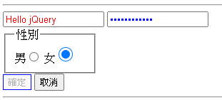

<!DOCTYPE html>

<html>

<head>

<meta charset="utf-8" />

<title>選擇器</title>

<script src="javascripts/jquery-3.6.1.min.js"></script>

<script>

$(function () {

$("div.c2 :text").css({ color: 'red' });

$("div.c2 :password").css({ color: 'blue' });

$("div.c2 :checked").css({ width: '20px', height:'20px'});

$("div.c2 :button:disabled").css({ border: '1px solid blue' });

</script>

</head>

<body>

<div class="c2">

<input type="text" size="15" value="Hello jQuery" />

<input type="password" size="15" value="Hello jQuery" />

<fieldset style="width:100px;">

<legend>性別</legend>

<label for="male">男</label><input type="radio" name="sex" id="male" />

<label for="female">女</label>

<input type="radio" name="sex" id="female" checked="checked" />

</fieldset>

<button type="button" disabled>確定</button>

<button type="button">取消</button>

</div>

</body>

</html>

## 基本過濾器(Basic Filter)

### 選擇器摘要

|  |  |  |
| --- | --- | --- |
| 選擇器 | 範例 | 說明 |
| :first * | $("p:first") | The first <p> element |
| :last * | $("p:last") | The last <p> element |
| :even * | $("tr:even") | All even <tr> elements |
| :odd * | $("tr:odd") | All odd <tr> elements |
| :eq(*index*) * | $("ul li:eq(3)") | The fourth element in a list(index starts at 0) |
| :gt(*no*) * | $("ul li:gt(3)") | List elements with an index greater than 3 |
| :lt(*no*) * | $("ul li:lt(3)") | List elements with an index less than 3 |
| :not(*selector*) | $("input:not([type=checkbox])") | All input elements that are not checkbox |
| :header * | $(":header") | All header elements <h1>, <h2> ... |

### 常用的「表單事件」相關API

#### jQuery物件.focus()

**.focus()**

* Bind an event handler to the“focus”JavaScript event, or trigger that event on an element.

### 範例程式：T02.html(Part III)

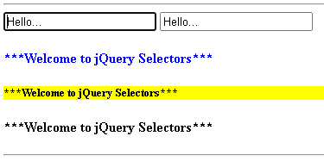

<!DOCTYPE html>

<html>

<head>

<meta charset="utf-8" />

<title>選擇器</title>

<script src="javascripts/jquery-3.6.1.min.js"></script>

<script>

$(function () {

$("div.c3 input:first").focus();

$("div.c3 h4:even").css({ color: "blue" });

$("div.c3 :header:not('h4')").css({ backgroundColor: "yellow" });

</script>

</head>

<body>

<div class="c3">

<input type="text" value="Hello..." />

<input type="text" value="Hello..." />

<h4>***Welcome to jQuery Selectors***</h4>

<h5>***Welcome to jQuery Selectors***</h5>

<h4>***Welcome to jQuery Selectors***</h4>

</div>

<hr />

</body>

</html>

# 選擇器 II

## 孩子過濾器(Child filter)

### 選擇器摘要

|  |  |  |
| --- | --- | --- |
| 選擇器 | 範例 | 說明 |
| :first-child | $("p:first-child") | All <p> elements that are the first child of their parent |
| :first-of-type | $("p:first-of-type") | All <p> elements that are the first <p> element of their parent |
| :last-child | $("p:last-child") | All <p> elements that are the last child of their parent |
| :last-of-type | $("p:last-of-type") | All <p> elements that are the last <p> element of their parent |
| :nth-child(*n*) | $("p:nth-child(2)") | All <p> elements that are the 2nd child of their parent (index starts at 1) |
| :nth-of-type(*n*) | $("p:nth-of-type(2)") | All <p> elements that are the 2nd <p> element of their parent |

### 範例程式：T03.html(Part I)

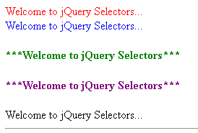

<!DOCTYPE html>

<html>

<head>

<meta charset="utf-8" />

<title>選擇器2</title>

<script src="javascripts/jquery-3.6.1.min.js"></script>

<script>

$(function () {

$("div.c1 div:first-child").css({ color: "red" });

$("div.c1 div:nth-child(2)").css({ color: "blue" });

$("div.c1 h4:first-of-type").css({ color: "green" });

$("div.c1 h4:nth-of-type(2)").css({ color: "purple" });

});

</script>

</head>

<body>

<div class="c1">

<div>Welcome to jQuery Selectors...</div>

<div>Welcome to jQuery Selectors...</div>

<h4>***Welcome to jQuery Selectors***</h4>

<h4>***Welcome to jQuery Selectors***</h4>

<div>Welcome to jQuery Selectors...</div>

</div>

</body>

</html>

## 內容過濾器(Content filter)

### 選擇器摘要

|  |  |  |
| --- | --- | --- |
| 選擇器 | 範例 | 說明 |
| :contains(*text*) * | $(":contains('Hello')")  1. 引號'可省略。  2. 關鍵字(Hello)前後不可有多餘的空白 | All elements which contains the text "Hello" |
| :has(*selector*) * | $("div:has(p)") | All <div> elements that have a <p> (子孫) element |
| :empty | $(":empty") | All elements that are empty |

### 範例程式：T03.html(Part II)

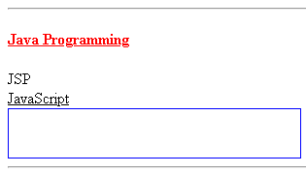

<!DOCTYPE html>

<html>

<head>

<meta charset="utf-8" />

<title>選擇器2</title>

<script src="javascripts/jquery-3.6.1.min.js"></script>

<script>

$(function () {

$("div.c2:contains(Java)").css({ "text-decoration": "underline" });

$("div.c2:has(span)").css({ "color": "red" });

$("div.c2:empty").css({ width: "300px", height: "50px", border: "1px blue solid" });

});

</script>

</head>

</head>

<body>

<div class="c2">

<h4>

<span>Java</span>

<span>Programming</span>

</h4>

</div>

<div class="c2">JSP</div>

<div class="c2">JavaScript</div>

<div class="c2"></div>

</body>

</html>

## 其他

### 選擇器摘要

|  |  |  |
| --- | --- | --- |
| 選擇器 | 範例 | 說明 |
| parent > child | $("div > p") | All <p> elements that are a direct child of a <div> element |
| parent descendant | $("div p") | All <p> elements that are descendants of a <div> element |
| element + next | $("div + p") | The <p> element that are next to each <div> elements  (Adjacent sibling) |
| :hidden * | $("p:hidden") | All hidden <p> elements (包含<head>區塊內) |
| :visible * | $("table:visible") | All visible tables |
| [*attribute*] | $("[href]") | All elements with a href attribute |
| [*attribute*=*value*] | $("[href='default.htm']") | All elements with a href attribute value equal to "default.htm"(value如含特殊字元，如.或空白，須以引號括起來) |
| [*attribute*!=*value*] | $("[href!='default.htm']") | All elements with a href attribute value not equal to "default.htm" |
| [*attribute*$=*value*] | $("[href$='.jpg']") | All elements with a href attribute value ending with ".jpg" |
| [*attribute*^=*value*] | $("[name^='hello']") | All elements with a name attribute value starting with "hello"(以hello開頭指hello後面接任意字串) |
| [*attribute\**=*value*] | $("[name*='hello']") | All elements with a name attribute value containing the string "hello" |

### 範例程式：T03.html(Part III)

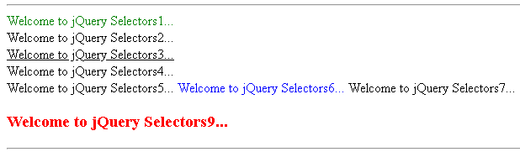

<!DOCTYPE html>

<html>

<head>

<meta charset="utf-8" />

<title>選擇器2</title>

<script src="javascripts/jquery-3.6.1.min.js"></script>

<script>

$(function () {

$("div.c3 .div-c3 > span:eq(0) + span").css({ color: "blue" });

$("div.c3 h3:visible").css({ color: "red" });

$("div.c3 [title='span 1']").css({ color: "green" });

$("div.c3 [title^='-sp']").css({ "text-decoration": "underline" } );

});

</script>

</head>

</head>

<body>

<div class="c3">

<div class="div-c3">

<div>

<span title="span 1">Welcome to jQuery Selectors1...</span>

<br />

<span title="+span 2">Welcome to jQuery Selectors2...</span>

<br />

<span title="-span 3">Welcome to jQuery Selectors3...</span>

<br />

<span title="*span 4">Welcome to jQuery Selectors4...</span>

</div>

</div>

<div class="div-c3">

<span>Welcome to jQuery Selectors5...</span>

<span>Welcome to jQuery Selectors6...</span>

<span>Welcome to jQuery Selectors7...</span>

</div>

<h3 style="display:none;">Welcome to jQuery Selectors8...</h3>

<h3>Welcome to jQuery Selectors9...</h3>

</div>

</body>

</html>

# 樣式控制 II

## 使用HTML元素之「類別(Class)」屬性

### 常用的「元素樣式」相關API

#### jQuery物件.addClass()

**.addClass( className )**

* Adds the specified class(es) to each element in the set of matched elements.
* Parameters:
  + - className
      * Type: String
      * One or more space-separated classes to be added to the class attribute of each matched element.
* Returns: jQuery

#### jQuery物件.removeClass()

**.removeClass( className )**

* Remove a single class or multiple classes from each element in the set of matched elements.
* Parameters:
  + - className
      * Type: String
      * One or more space-separated classes to be removed from the class attribute of each matched element.
* Returns: jQuery

### 範例程式：T04.html(第一頁)

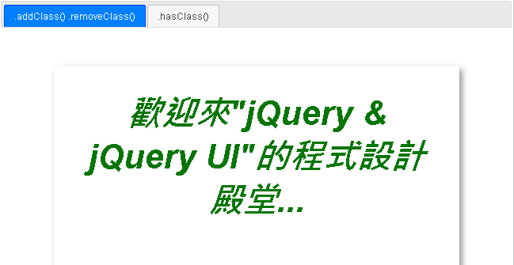

<!DOCTYPE html>

<html>

<head>

<meta charset="utf-8" />

<title>樣式控制 2</title>

<link rel="icon" href="./favicon.ico" />

<style type="text/css">

.main-box {

margin: 50px auto;

width: 600px;

height: 300px;

padding: 40px;

box-shadow: 5px 5px 10px #999;

border: 1px solid #fff;

text-align: center;

overflow:auto;

}

.my-style {

font-style: italic;

color: green;

font-size: 1.5cm;

font-weight: bold;

transition: font-size 2s, color 5s;

/*transition(轉場/過渡/漸變 動畫): transition-property transition-duration, ... ;

CSS transitions allows you to change property values smoothly, over a given duration.

To create a transition effect, you must specify two things:

1. the CSS property you want to add an effect to

2. the duration of the effect(預設0)

*/

}

(略)

</style>

<link href="stylesheets/jquery-ui/base/jquery-ui.min.css" rel="stylesheet" />

<script src="javascripts/jquery-3.6.1.min.js"></script>

<script src="javascripts/jquery-ui.min.js"></script>

<script type="text/javascript">

$(function () {

$("#tabs").tabs();

$("#p1 #div1").hover(

function () { $(this).addClass("my-style") },

function () { $(this).removeClass("my-style") }

);

(略)

});

</script>

</head>

<body>

<div id="tabs">

<ul>

<li><a href="#p1">.addClass() .removeClass(</a></li>

<li><a href="#p2">.hasClass()</a></li>

</ul>

<div id="p1">

<div class="main-box">

<div id="div1">

歡迎來&quot;jQuery &amp; jQuery UI&quot;的程式設計殿堂...

</div>

</div>

</div>

(略)

</div>

</body>

</html>

## 判斷HTML元素之「類別(Class)」屬性

### 常用的「元素樣式」相關API

#### jQuery物件.hasClass()

**.hasClass( className )**

* Determine whether any of the matched elements are assigned the given class.
* Parameters:
  + - className
      * Type: String
      * The class name to search for.
* Returns: Boolean

### 常用的「特效與動畫」相關API

#### jQuery物件.hide()

**.hide( )**

* The matched elements will be hidden immediately, with no animation.
* Returns: jQuery

**.hide( duration [, easing ] [, complete ] )**

* Hide the matched elements with animation.
* Parameters:
  + - duration (default: 400)
      * Type: Number or String
      * A string or number determining how long the animation will run.
    - easing (default: swing)
      * Type: String
      * A string indicating which easing function to use for the transition.
    - complete
      * Type: Function()
      * A function to call once the animation is complete, called once per matched element.
* Returns: jQuery

#### jQuery物件.show()

**.show( )**

* The matched elements will be revealed immediately, with no animation.
* Returns: jQuery

**.show( duration [, easing ] [, complete ] )**

* Display the matched elements with animation.
* Parameters:
  + - duration (default: 400)
      * Type: Number or String
      * A string or number determining how long the animation will run.
    - easing (default: swing)
      * Type: String
      * A string indicating which easing function to use for the transition.
    - complete
      * Type: Function()
      * A function to call once the animation is complete, called once per matched element.
* Returns: jQuery

#### jQuery物件.slideDown()

**.slideDown( [duration ] [, easing ] [, complete ] )**

* Display the matched elements with a sliding motion.
* Parameters:
  + - duration (default: 400)
      * Type: Number or String
      * A string or number determining how long the animation will run.
    - easing (default: swing)
      * Type: String
      * A string indicating which easing function to use for the transition.
    - complete
      * Type: Function()
      * A function to call once the animation is complete, called once per matched element.
* Returns: jQuery

#### jQuery物件.slideUp()

**.slideUp( [duration ] [, easing ] [, complete ] )**

* Hide the matched elements with a sliding motion.
* Parameters:
  + - duration (default: 400)
      * Type: Number or String
      * A string or number determining how long the animation will run.
    - easing (default: swing)
      * Type: String
      * A string indicating which easing function to use for the transition.
    - complete
      * Type: Function()
      * A function to call once the animation is complete, called once per matched element.
* Returns: jQuery

#### jQuery物件.slideToggle()

**.slideToggle( [duration ] [, easing ] [, complete ] )**

* Display or hide the matched elements with a sliding motion.
* Parameters:
  + - duration (default: 400)
      * Type: Number or String
      * A string or number determining how long the animation will run.
    - easing (default: swing)
      * Type: String
      * A string indicating which easing function to use for the transition.
    - complete
      * Type: Function()
      * A function to call once the animation is complete, called once per matched element.
* Returns: jQuery

#### jQuery物件.fadeIn()

**.fadeIn( [duration ] [, easing ] [, complete ] )**

* Display the matched elements by fading them to opaque.
* Parameters:
  + - duration (default: 400)
      * Type: Number or String
      * A string or number determining how long the animation will run.
    - easing (default: swing)
      * Type: String
      * A string indicating which easing function to use for the transition.
    - complete
      * Type: Function()
      * A function to call once the animation is complete, called once per matched element.
* Returns: jQuery

#### jQuery物件.fadeOut()

**.fadeOut( [duration ] [, easing ] [, complete ] )**

* Hide the matched elements by fading them to transparent.
* Parameters:
  + - duration (default: 400)
      * Type: Number or String
      * A string or number determining how long the animation will run.
    - easing (default: swing)
      * Type: String
      * A string indicating which easing function to use for the transition.
    - complete
      * Type: Function()
      * A function to call once the animation is complete, called once per matched element.
* Returns: jQuery

#### jQuery物件.fadeToggle()

**.fadeToggle( [duration ] [, easing ] [, complete ] )**

* Display or hide the matched elements by animating their opacity.
* Parameters:
  + - duration (default: 400)
      * Type: Number or String
      * A string or number determining how long the animation will run.
    - easing (default: swing)
      * Type: String
      * A string indicating which easing function to use for the transition.
    - complete
      * Type: Function()
      * A function to call once the animation is complete, called once per matched element.
* Returns: jQuery

### 常用的「DOM元素的操作」相關API

#### jQuery物件.next()

**.next( [selector] )**

* Get the immediately following sibling of each element in the set of matched elements. If a selector is provided, it retrieves the next sibling only if it matches that selector.
* Parameters:
  + - selector
      * Type: Selector
      * A string containing a selector expression to match elements against.
* Returns: jQuery

#### jQuery物件.prev()

**.prev( [selector] )**

* Get the immediately preceding sibling of each element in the set of matched elements. If a selector is provided, it retrieves the previous sibling only if it matches that selector.
* Parameters:
  + - selector
      * Type: Selector
      * A string containing a selector expression to match elements against.
* Returns: jQuery

### CSS選擇器的優先順序

* 選擇器的優先順序是依其具體性(selector's specificity)的等級來計分。
* 當兩個選擇器同時作用在一個元素時，具體性高的選擇器優先生效。
* 選擇器的具體性等級的計分規則：

|  |  |  |
| --- | --- | --- |
| **順序** | **規則** | **結果** |
| 1 | style="樣式表" | a=1, b=0, c=0, d=0 |
| 2 | Id選擇器 | a=0, b=1, c=0, d=0 |
| 3 | 其他**屬性或假類別**選擇器 | a=0, b=0, c=1, d=0 |
| 4 | **元素或假元素**選擇器 | a=0, b=0, c=0, d=1 |

* 選擇器的具體性等級的計分範例：

|  |  |  |
| --- | --- | --- |
| 1 | * {} | a=0 b=0 c=0 d=0 |
| 2 | li {} | a=0 b=0 c=0 d=1 |
| 3 | li:first-line {} | a=0 b=0 c=0 d=2 |
| 4 | ul li {} | a=0 b=0 c=0 d=2 |
| 5 | ul ol+li {} | a=0 b=0 c=0 d=3 |
| 6 | h1 + *[rel=up] {} | a=0 b=0 c=1 d=1 |
| 7 | ul ol li.red {} | a=0 b=0 c=1 d=3 |
| 8 | li.red.level {} | a=0 b=0 c=2 d=1 |
| 9 | #x34y {} | a=0 b=1 c=0 d=0 |
| 10 | style="" | a=1 b=0 c=0 d=0 |

* + 實例1

<html>

<head>

<title>CSS Specificity</title>

<style type="text/css">

li.red.level {color:red;}

ul ol li.red { color:green;}

</style>

</head>

<body style="font-size:1cm;">

<ul>

<li>Programming Language

<ol>

<li class="red level">JavaScript</li>

<li>jQuery</li>

</ol>

</li>

<li>Database</li>

</ul>

</body>

</html>

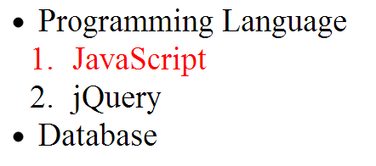

* + 實例2

<style type="text/css">

ul [class].red { color:green;}

li.red.level {color:red;}

|  |
| --- |
| 優先權相同時，以位置在**後**者為準 |

</style>

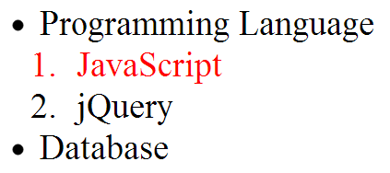

* + 實例3

<style type="text/css">

<style type="text/css">

li.red.level {color:red;}

ul ol li.red { color:green!important;}

</style>

</style>

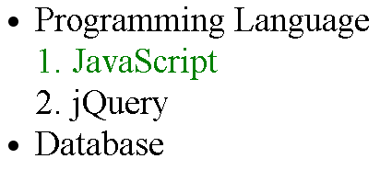

### 範例程式：T04.html(第二頁)

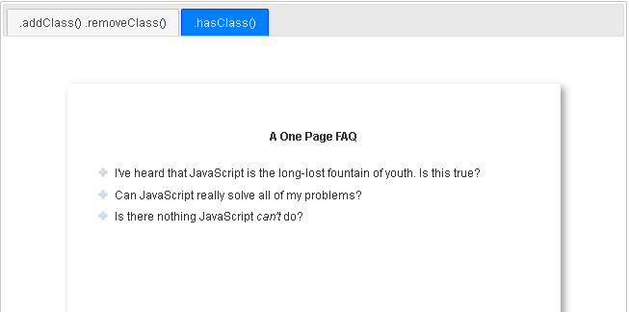

<!DOCTYPE html>

<html>

<head>

<meta charset="utf-8" />

<title>樣式控制 2</title>

<link rel="icon" href="./favicon.ico" />

<style type="text/css">

(略)

#p2 div.question {

text-align:left;

background: url(images/open.png) no-repeat 0 11px;

padding: 10px 0 0 25px; cursor: pointer;

}

#p2 div.question.close {

background-image: url(images/close.png);

}

#p2 div.answer {

text-align:left; margin-left: 25px;

}

</style>

<link href="stylesheets/jquery-ui/base/jquery-ui.min.css" rel="stylesheet" />

<script src="javascripts/jquery-3.6.1.min.js"></script>

<script src="javascripts/jquery-ui.min.js"></script>

<script type="text/javascript">

$(function () {

$("#tabs").tabs();

(略)

$('#p2 .answer').hide();

$('#p2 .question').click(

function () {

if ($(this).hasClass('close')) {

$(this).next().fadeOut();

$(this).removeClass('close');

}

else {

$(this).next().slideDown();

$(this).addClass('close');

}

}

);

});

</script>

</head>

<body>

<div id="tabs">

<ul>

<li><a href="#p1">.addClass() .removeClass()</a></li>

<li><a href="#p2">.hasClass()</a></li>

</ul>

(略)

<div id="p2">

<div class="main-box">

<h4>A One Page FAQ</h4>

<div class="question">I've heard that JavaScript is the long-lost fountain of youth. Is this true?</div>

<div class="answer">

<p>Why, yes it is! Studies prove that learning JavaScript freshens the mind and extends life span

by several hundred years. (Note: some scientists disagree with these claims.)</p>

</div>

<div class="question">Can JavaScript really solve all of my problems?</div>

<div class="answer">

<p>Why, yes it can! It's the most versatile programming language ever created and is trained to

provide financial management advice, life-saving CPR, and even to take care of household pets.</p>

</div>

<div class="question">Is there nothing JavaScript <em>can&#8217;t</em> do?</div>

<div class="answer">

<p>Why, no there isn&#8217;t! It&#8217;s even able to write its own public relations-oriented

Frequently Asked Questions pages. Now that&#8217;s one smart programming language!</p>

</div>

</div>

</div>

</div>

</body>

</html>

# 事件處理—滑鼠事件

## jQuery支援的常用滑鼠事件

* .click()
  + Bind an event handler to the “click” JavaScript event, or trigger that event on an element.
* .dblclick()：
  + Bind an event handler to the “dblclick” JavaScript event, or trigger that event on an element.
* .contextmenu()：
  + Bind an event handler to the “contextmenu” JavaScript event, or trigger that event on an element.
* .mousedown()
  + Bind an event handler to the “mousedown” JavaScript event, or trigger that event on an element.
* .mouseup()
  + Bind an event handler to the “mouseup” JavaScript event, or trigger that event on an element.
* .mouseenter()
  + Bind an event handler to be fired when the mouse enters an element, or trigger that handler on an element.
* .mouseleave()
  + Bind an event handler to be fired when the mouse leaves an element, or trigger that handler on an element.
* .hover()
  + Bind one or two handlers to the matched elements, to be executed when the mouse pointer enters and leaves the elements.
* .mouseout()
  + Bind an event handler to the “mouseout” JavaScript event, or trigger that event on an element.
* .mouseover()
  + Bind an event handler to the “mouseover” JavaScript event, or trigger that event on an element.

## Click事件使用範例

### 常用的「滑鼠事件」相關API

#### jQuery物件.click()

**.click( handler )**

* Bind an event handler to the "click" JavaScript event, or trigger that event on an element.
* Parameters:
  + - handler
      * Type: Function( Event eventObject )
      * A function to execute each time the event is triggered.
* Returns: jQuery

### 常用的「表單輸入」相關API

#### jQuery物件.val()

**.val()**

* Get the current value of the first element(<input>) in the set of matched elements.
* Returns: String or Number or Array

**.val( value )**

* Set the value of each element (<input>) in the set of matched elements.
* Parameters:
  + - value
      * Type: String or Number or Array
      * A string of text, a number, or an array of strings corresponding to the value of each matched element to set as selected/checked.
* Returns: jQuery

### 範例程式：T05.html(第一頁)

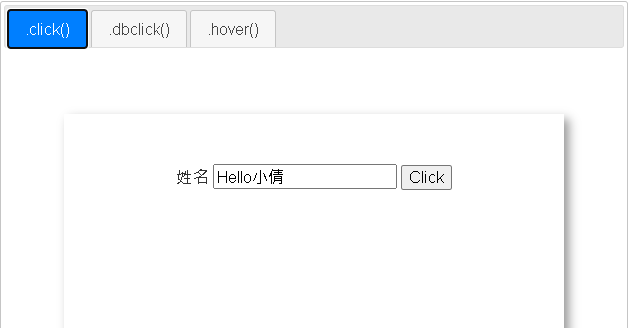

<!DOCTYPE html>

<html>

<head>

<meta charset="utf-8" />

<title>使用滑鼠事件範例1</title>

<link rel="icon" href="./favicon.ico" />

<link href="stylesheets/jquery-ui/base/jquery-ui.min.css" rel="stylesheet" />

<style>

.main-box {

margin: 50px auto; width: 400px;

height: 200px; padding: 50px;

box-shadow: 5px 5px 10px #999; border: 1px solid #fff;

text-align: center; overflow: auto;

}

(略)

</style>

<script src="javascripts/jquery-3.6.1.min.js"></script>

<script src="javascripts/jquery-ui.min.js"></script>

<script type="text/javascript">

$(function () {

$("#tabs").tabs();

$("#p1 #button1").click(

function () { alert("歡迎" + $("#text1").val() + "光臨!"); }

);

(略)

});

</script>

</head>

<body>

<div id="tabs">

<ul>

<li><a href="#p1">.click()</a></li>

<li><a href="#p2">.dblclick()</a></li>

<li><a href="#p3">.hover()</a></li>

</ul>

<div id="p1">

<div class="main-box">

<label>

姓名

<input type="text" id="text1" size="20" value="Hello小倩" />

</label>

<input type="button" id="button1" value="Click" />

</div>

</div>

(略)

</div>

</body>

</html>

## Dblclick事件使用範例

### 常用的「滑鼠事件」相關API

#### jQuery物件.dblclick()

**.dblclick( handler )**

* Bind an event handler to the "dblclick" JavaScript event, or trigger that event on an element.
* Parameters:
  + - handler
      * Type: Function( Event eventObject )
      * A function to execute each time the event is triggered.
* Returns: jQuery

### 常用的「元素屬性值」相關API

#### jQuery物件.attr()

**.attr( attributeName, value )**

* Set one or more attributes for the set of matched elements.
* Parameters:
  + - attributeName
      * Type: String
      * The name of the attribute to set.
    - value
      * Type: String or Number or Null
      * A value to set for the attribute. If null, the specified attribute will be removed (as in .removeAttr()).
* Returns: jQuery

**.attr( attributes )**

* Set one or more attributes for the set of matched elements.
* Parameters:
  + - attributes
      * Type: PlainObject
      * An object of attribute-value pairs to set.
* Returns: jQuery

**.attr( attributeName )**

* Get the value of an attribute for the first element in the set of matched elements.
* Parameters:
  + - attributeName
      * Type: String
      * The name of the attribute to get.
* Returns: String

|  |
| --- |
| .attr() 與 .prop() 函式用法比較  <input type=*"text"* disabled data-xxx=*"custom-attribute"* id=*"my-text"*/>  <script>  console.log($("#my-text").attr("disabled")); //disabled (String型別)  console.log($("#my-text").prop("disabled")); //true (Boolean型別)  console.log($("#my-text").attr("data-xxx")); //custom-attribute (String型別)  console.log($("#my-text").prop("data-xxx")); //undefined (Undefined型別)  </script> |

#### jQuery物件.prop()

**.prop( propertyName, value )**

* Set one or more properties for the set of matched elements.
* Parameters:
  + - propertyName
      * Type: String
      * The name of the property to set.
    - value
      * Type: Anything
      * A value to set for the property.
* Returns: jQuery

**.prop( properties )**

* Set one or more properties for the set of matched elements.
* Parameters:
  + - properties
      * Type: PlainObject
      * An object of property-value pairs to set.
* Returns: jQuery

**.prop(propertyName )**

* Get the value of a property for the first element in the set of matched elements.
* Parameters:
  + - propertyName
      * Type: String
      * The name of the property to get.
* Returns: Anything

### 常用的「特效與動畫」相關API

#### jQuery物件.animate()

**.animate( properties [, duration ] [, easing ] [, complete ] )**

* Perform a custom animation of a set of CSS properties.
* Parameters:
  + - properties
      * Type: PlainObject
      * An object of CSS properties and values that the animation will move toward.
    - duration (default: 400)
      * Type: Number or String
      * A string or number determining how long the animation will run.
    - easing (default: swing)
      * Type: String
      * A string indicating which easing function to use for the transition.
        + Easing functions specify the speed at which an animation progresses at different points within the animation.
        + jQuery core ships with two easings: linear, which progresses at a constant pace throughout the animation, and swing (jQuery core's default easing), which progresses slightly slower at the beginning and end of the animation than it does in the middle of the animation.
        + jQuery UI provides several additional easing functions, ranging from variations on the swing behavior to customized effects such as bouncing.

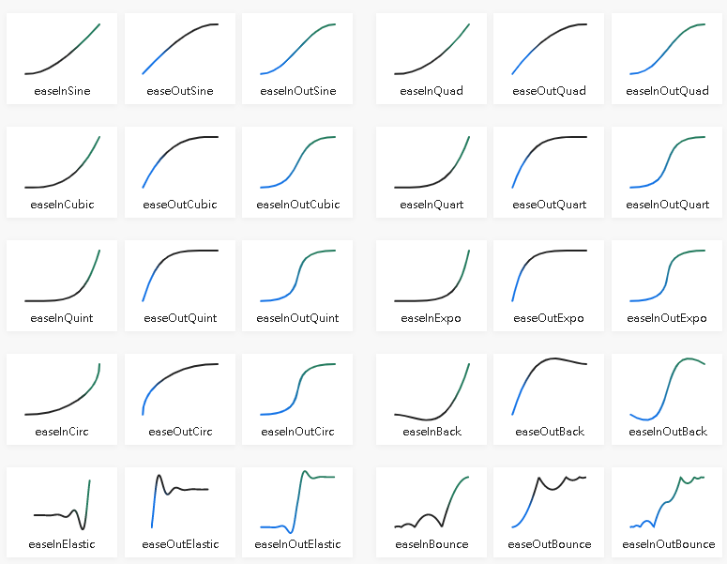

參考資料來源：https://easings.net/

* + - complete
      * Type: Function()
      * A function to call once the animation is complete, called once per matched element.
* Returns: jQuery

### 範例程式：T05.html(第二頁)

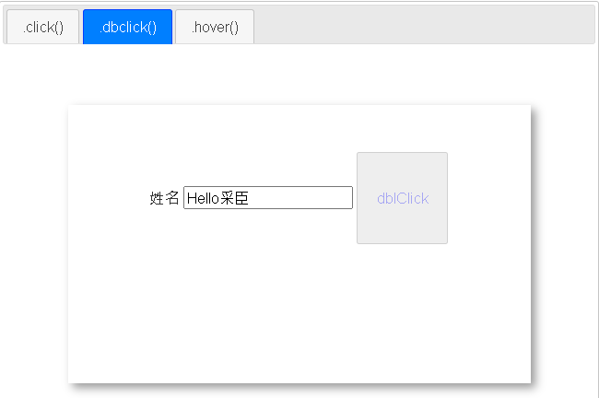

<!DOCTYPE html>

<html>

<head>

<meta charset="utf-8" />

<title>使用滑鼠事件範例1</title>

<link rel="icon" href="./favicon.ico" />

<link href="stylesheets/jquery-ui/base/jquery-ui.min.css" rel="stylesheet" />

<style>

(略)

</style>

<script src="javascripts/jquery-3.6.1.min.js"></script>

<script src="javascripts/jquery-ui.min.js"></script>

<script type="text/javascript">

$(function () {

$("#tabs").tabs();

(略)

$("#p2 #button2").dblclick(function () {

$(this).attr("disabled", true).css("color", "rgba(0,0,255,0.3) ") ;

//註：jq.attr("disabled", true)==jq.attr("disabled", "disabled")

==jq.prop("disabled", true)==jq.prop("disabled", "disabled")

// console.log($(this).attr("disabled"));//disabled(字串值)

// console.log($(this).prop("disabled"));//true(布林值)

var btnWidth = $(this).css("width");

var btnHeight = $(this).css("height");

$(this).animate({ width: "100px", height: "100px" }, 1000, function () {

$(this).animate({ width: btnWidth, height: btnHeight }, 2000, function () {

$(this).attr("disabled", false).css("color", "");

})

});

});

(略)

});

</script>

</head>

<body>

<div id="tabs">

<ul>

<li><a href="#p1">.click()</a></li>

<li><a href="#p2">.dblclick()</a></li>

<li><a href="#p3">.hover()</a></li>

</ul>

(略)

<div id="p2">

<div class="main-box">

<label>

姓名

<input type="text" id="text2" size="20" value="Hello采臣" />

</label>

<input type="button" id="button2" value="Click" />

</div>

</div>

(略)

</div>

</body>

</html>

## Hover事件使用範例

### 常用的「滑鼠事件」相關API

#### jQuery物件.hover()

**.hover( handlerIn, handlerOut )**

* Bind two handlers to the matched elements, to be executed when the mouse pointer enters and leaves the elements.
* Parameters:
  + - handlerIn
      * Type: Function( Event eventObject )
      * A function to execute when the mouse pointer enters the element.
    - handlerOut
      * Type: Function( Event eventObject )
      * A function to execute when the mouse pointer leaves the element.
* Returns: jQuery

### 常用的「特效與動畫」相關API

#### jQuery物件.stop()

**.stop( )**

* Stop the currently-running animation on the matched elements.
* Returns: jQuery

### 範例程式：T05.html(第三頁)

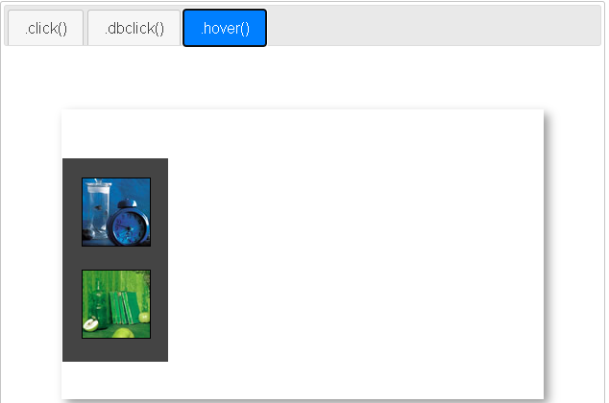

<!DOCTYPE html>

<html>

<head>

<meta charset="utf-8" />

<title>使用滑鼠事件範例1</title>

<link rel="icon" href="./favicon.ico" />

<link href="stylesheets/jquery-ui/base/jquery-ui.min.css" rel="stylesheet" />

<style>

.main-box {

margin: 50px auto; width: 400px;

height: 200px; padding: 50px;

box-shadow: 5px 5px 10px #999; border: 1px solid #fff;

text-align: center; overflow: auto;

}

.dashboard {

width: 70px;

background-color: rgb(110,138,195);

padding: 20px 20px 0 20px;

position: absolute;

left: -92px;

z-index: 100;

}

.dashboard img {

margin-bottom: 20px;

border: 1px solid rgb(0,0,0);

}

</style>

<script src="javascripts/jquery-3.6.1.min.js"></script>

<script src="javascripts/jquery-ui.min.js"></script>

<script type="text/javascript">

$(function () {

$("#tabs").tabs();

(略)

$('#p3 .dashboard').hover(

function () {

$(this).stop().animate(

{

left: '0px',

backgroundColor: '#444'

},

500,

'easeInSine'

); // end animate

},

function () {

$(this).stop().animate(

{

left: '-92px',

backgroundColor: 'rgb(110,138,195)'

},

1500,

'easeOutBounce'

); // end animate

}

); // end hover

});

</script>

</head>

<body>

<div id="tabs">

<ul>

<li><a href="#p1">.click()</a></li>

<li><a href="#p2">.dblclick()</a></li>

<li><a href="#p3">.hover()</a></li>

</ul>

(略)

<div id="p3">

<div class="main-box" style="position:relative">

<div class="dashboard">

<img src="images/small/blue_h.jpg" width="70" height="70" alt="blue">

<img src="images/small/green_h.jpg" width="70" height="70" alt="green">

</div>

</div>

</div>

</div>

</body>

</html>

# 事件處理—表單事件

## jQuery支援的常用表單事件

* .submit()
  + Bind an event handler to the “submit” JavaScript event, or trigger that event on an element.
* .focus()
  + Bind an event handler to the “focus” JavaScript event, or trigger that event on an element.
* .blur()
  + Bind an event handler to the “blur” JavaScript event, or trigger that event on an element.
* .change()
  + Bind an event handler to the “change” JavaScript event, or trigger that event on an element.

## Submit、Blur事件使用範例

### 常用的「表單事件」相關API

#### jQuery物件.submit()

**.submit( [handler] )**

* Bind an event handler to the “submit” JavaScript event, or trigger that event on an element.
* Parameters:
  + - handler
      * Type: Function( Event eventObject )
      * A function to execute each time the event is triggered.
* Returns: jQuery

#### jQuery物件.blur()

**.blur( [handler] )**

* Bind an event handler to the "blur" JavaScript event, or trigger that event on an element.
* Parameters:
  + - handler
      * Type: Function( Event eventObject )
      * A function to execute each time the event is triggered.
* Returns: jQuery

#### jQuery物件.focus()

**.focus( [handler] )**

* Bind an event handler to the "focus" JavaScript event, or trigger that event on an element.
* Parameters:
  + - handler
      * Type: Function( Event eventObject )
      * A function to execute each time the event is triggered.
* Returns: jQuery

### 常用的「工具函式」相關API

#### jQuery物件.each()

**.each( function )**

* Iterate over a jQuery object, executing a function for each matched element.
* Parameters:
  + - function
      * Type: Function( Integer index, Element element )
      * A function to execute for each matched element.
* Returns: jQuery

#### jQuery物件.position()

**.position( options )** (jQueryUI API)

* Position an element relative to another.
* Parameters:
  + - options (Type: Object)
      * my屬性 (default: "center") (Type: String)
        + Defines which position on the element being positioned to align with the target element: "horizontal vertical" alignment.
        + A single value such as "right" will be normalized to "right center", "top" will be normalized to "center top" (following CSS convention).
        + Acceptable horizontal values: "left", "center", "right". Acceptable vertical values: "top", "center", "bottom". Example: "left top" or "center center". Each dimension can also contain offsets, in pixels or percent, e.g., "right+10 top-25%". Percentage offsets are relative to the element being positioned.
      * at屬性(default: "center")(Type: String)
        + Defines which position on **the target element** to align the positioned element against: "horizontal vertical" alignment.
      * of屬性(default: null)(Type: Selector or Element or jQuery)
        + Which element to position against. If you provide a selector or jQuery object, the first matching element will be used. Example: "#top-menu"
* Returns: jQuery

### 常用的「DOM元素的操作」相關API

#### jQuery物件.append() 附加么子

**.append( content )**

* Insert content, specified by the parameter, to the end of each element in the set of matched elements.
* Parameters:
  + - content
      * Type: htmlString or Element or Text or Array or jQuery
      * DOM element, text node, array of elements and text nodes, HTML string, or jQuery object to insert at the end of each element in the set of matched elements.
* Returns: jQuery

#### jQuery物件.prepend() 附加長子

**.prepend( content)**

* Insert content, specified by the parameter, to the beginning of each element in the set of matched elements.
* Parameters:
  + - content
      * Type: htmlString or Element or Text or Array or jQuery
      * DOM element, text node, array of elements and text nodes, HTML string, or jQuery object to insert at the beginning of each element in the set of matched elements.
* Returns: jQuery

#### jQuery物件.after() 使…在後

**.after( content )**

* Insert content, specified by the parameter, after each element in the set of matched elements.
* Parameters:
  + - content
      * Type: htmlString or Element or Text or Array or jQuery
      * HTML string, DOM element, text node, array of elements and text nodes, or jQuery object to insert after each element in the set of matched elements.
* Returns: jQuery
* 例如：

<!DOCTYPE html>

<html>

<head>

<script src="javascripts/jquery-3.6.1.min.js"></script>

<script type="text/javascript">

$(function () {

$("h1").after("<div style='color:red;'>歡迎光臨</div>");

});

</script>

</head>

<body>

<div>

<h1>Hello World 1</h1>

<h2>Hello World</h2>

<h1>Hello World 2</h1>

</div>

</body>

</html>

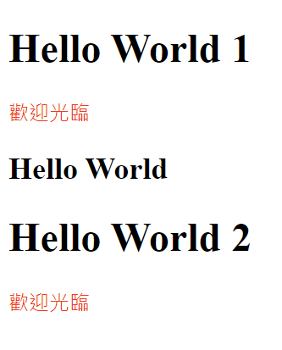

#### jQuery物件.before() 使…在前

**.before( content )**

* Insert content, specified by the parameter, before each element in the set of matched elements.
* Parameters:
  + - content
      * Type: htmlString or Element or Text or Array or jQuery
      * HTML string, DOM element, text node, array of elements and text nodes, or jQuery object to insert before each element in the set of matched elements.
* Returns: jQuery
* 例如：

<!DOCTYPE html>

<html>

<head>

<script src="javascripts/jquery-3.6.1.min.js"></script>

<script type="text/javascript">

$(function () {

$("h1").before("<div style='color:red;'>歡迎光臨</div>");

});

</script>

</head>

<body>

<div>

<h1>Hello World 1</h1>

<h2>Hello World</h2>

<h1>Hello World 2</h1>

</div>

</body>

</html>

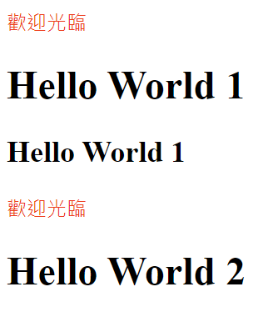

#### jQuery物件.insertAfter()

.**insertAfter( target )**

* Insert every element in the set of matched elements after the target.
* Parameters:
  + - target
      * Type: Selector or htmlString or Element or Array or jQuery
      * A selector, element, array of elements, HTML string, or jQuery object; the matched set of elements will be inserted after the element(s) specified by this parameter.
* Returns: jQuery
* 例如：

<!DOCTYPE html>

<html>

<head>

<script src="javascripts/jquery-3.6.1.min.js"></script>

<script type="text/javascript">

$(function () {

$("<div style='color:red;'>歡迎光臨</div>").insertAfter("h1");

});

</script>

</head>

<body>

<div>

<h1>Hello World 1</h1>

<h2>Hello World</h2>

<h1>Hello World 2</h1>

</div>

</body>

</html>



#### jQuery物件.insertBefore()

**.insertBefore( target )**

* Insert every element in the set of matched elements before the target.
* Parameters:
  + - target
      * Type: Selector or htmlString or Element or Array or jQuery
      * A selector, element, array of elements, HTML string, or jQuery object; the matched set of elements will be inserted before the element(s) specified by this parameter.
* Returns: jQuery
* 例如：

<!DOCTYPE html>

<html>

<head>

<script src="javascripts/jquery-3.6.1.min.js"></script>

<script type="text/javascript">

$(function () {

$("<div style='color:red;'>歡迎光臨</div>").insertBefore("h1");

});

</script>

</head>

<body>

<div>

<h1>Hello World 1</h1>

<h2>Hello World</h2>

<h1>Hello World 2</h1>

</div>

</body>

</html>



#### jQuery物件.remove()

**.remove( [selector ] )**

* Remove the set of matched elements from the DOM.
* Parameters:
  + - selector
      * Type: String
      * A selector expression that filters the set of matched elements to be removed.
* Returns: jQuery

### Client/Server範例程式

#### 用戶端範例程式：T06.html(第一頁)

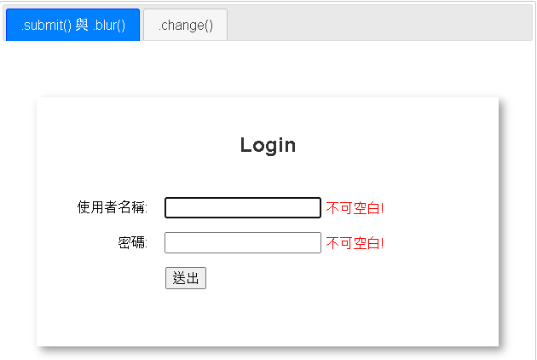

<!DOCTYPE html>

<html>

<head>

<meta charset="utf-8" />

<title>表單事件(Form Event)</title>

<link rel="icon" href="./favicon.ico" />

<style type="text/css">

.main-box {

margin: 50px auto;

width: 500px;

height: 250px;

padding: 20px;

box-shadow: 5px 5px 10px #999;

border: 1px solid #fff;

text-align: center;

}

#p1 form, #p2 form {

padding: 10px 10px 10px 10px;

text-align: left;

}

#p1 label, #p2 label {

display: inline-block;

width: 100px;

text-align: right;

margin: 0 15px 0 0;

color: black;

}

#p1 #button1 {

margin-left: 120px;

}

#p1 #fail{

color: red;

}

#p1 .success {

color: blue;

}

#p1 .errMsg {

position: absolute;

color: red;

}

(略)

</style>

<link href="stylesheets/jquery-ui/base/jquery-ui.min.css" rel="stylesheet" />

<script src="javascripts/jquery-3.6.1.min.js"></script>

<script src="javascripts/jquery-ui.min.js"></script>

<script type="text/javascript">

$(function () {

$("#tabs").tabs();

function createErrMsgElement(input) {

var errMsgId = `err-${$(input).attr('id')}`; //例如: err-username

var errMsg = $(`<div id='${errMsgId}' class='errMsg'>不可空白!</div>`);

$("#p1").append(errMsg);

errMsg.position({

of: input, //定位被對準的元素

my: "left+5px center", //定位時本身元素的 x y 位置

at: "right center" //定位時被對準的元素的 x y 位置

});

}

//<input>失去焦點時，檢查其值不可空白

$("#p1 :text").blur(function () {

var errMsgId = `#err-${$(this).attr('id')}`; //例如: #err-username

if ($(this).val() != '') {

if ($(errMsgId).length > 0)

$(errMsgId).remove();

}

else {

if ($(errMsgId).length <= 0)

createErrMsgElement(this);

}

});

//<form>提交時

$('#p1 #login-form').submit(

function () {

//重新從頭檢查每個<input>不可空白

$(".errMsg").remove();

var errs = [];

$("#p1 input").each(function () {

if ($(this).val() == '') {

createErrMsgElement(this);

errs.push(this);

}

});

if (errs.length > 0) {

$(errs[0]).focus();

return false;//阻止submit事件預設行為

}

}

); // end submit

(略)

});

</script>

</head>

<body>

<div id="tabs">

<ul>

<li><a href="#p1">.submit() 與 .blur()</a></li>

<li><a href="#p2">.change()</a></li>

</ul>

<div id="p1">

<div class="main-box">

<h2>Login</h2>

<div id="formwrapper">

<form method="get" action="processLogin.aspx" id="login-form">

<p>

<label for="username">使用者名稱:</label>

<input type="text" name="username" id="username"

autocomplete="off" >

</p>

<p>

<label for="password">密碼: </label>

<input type="text" name="password" id="password"

autocomplete="off">

</p>

<p>

<button id="button1">送出</button>

</p>

</form>

</div>

</div>

</div>

(略)

</div>

</body>

</html>

#### 伺服端範例程式：JqController.cs、Login.cshtml

WebApplication1\Controllers\JqController.cs

using Microsoft.AspNetCore.Mvc;

namespace WebApplication1.Controllers

{

public class JqController : Controller

{

[HttpGet]

public IActionResult Index()

{

return View();

}

[HttpGet, HttpPost]

public IActionResult Login(string username, string password)

{

if (username == "hello" && password == "kitty")

ViewData["LoginStatus"] = "pass";

else

ViewData["LoginStatus"] = "fail";

return View();

}

}

}

WebApplication1\Views\Jq\Login.cshtml

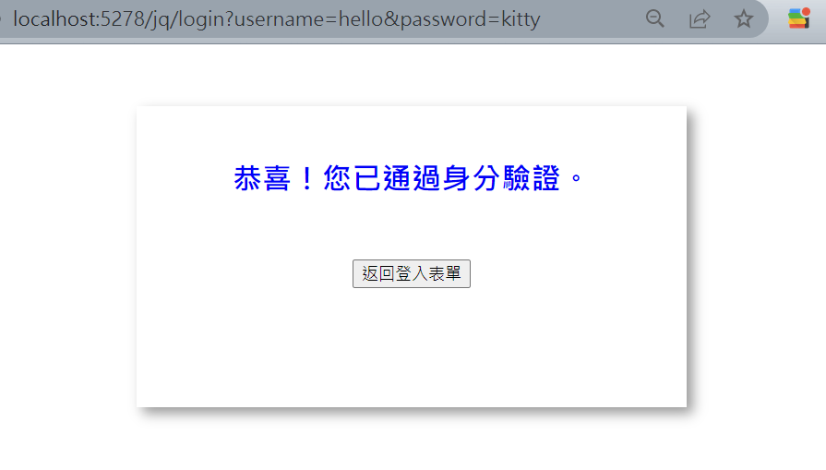

<!DOCTYPE html>

<html>

<head>

<meta charset="utf-8" />

<title></title>

<link rel="icon" href="./favicon.ico" />

<style type="text/css">

.main-box {

margin: 50px auto;

width: 400px;

height: 200px;

padding: 20px;

box-shadow: 5px 5px 10px #999;

border: 1px solid #fff;

text-align: center;

}

.success {

color: blue;

}

.fail {

color: red;

}

</style>

</head>

<body>

<div class="main-box">

@if( (ViewData["LoginStatus"] as string)=="pass"){

<h2 class='success'>恭喜！您已通過身分驗證。</h2>

}

else{

<h2 class='fail'>糟糕！您未通過身分驗證。</h2>

}

<div style="text-align: center; margin-top:50px;">

<button onclick="history.back()">返回登入表單</button>

</div>

</div>

</body>

</html>

## Change事件使用範例

### 常用的「表單事件」相關API

#### jQuery物件.change()

**.change( handler )**

* Bind an event handler to the "change" JavaScript event, or trigger that event on an element.
* Parameters:
  + - handler
      * Type: Function( Event eventObject )
      * A function to execute each time the event is triggered.
* Returns: jQuery

### 常用的「元素內容」相關API

#### jQuery物件.html()

**.html()**

* Get the HTML contents of the first element in the set of matched elements.
* Returns: String

**.html( htmlString )**

* Set the HTML contents of each element in the set of matched elements.
* Parameters:
  + - htmlString
      * Type: htmlString
      * A string of HTML to set as the content of each matched element.
* Returns: jQuery

#### jQuery物件.text()

**.text()**

* Get the combined text contents of each element in the set of matched elements, including their descendants.
* Returns: String

**.text( text )**

* Set the content of each element in the set of matched elements to the specified text.
* Parameters:
  + - text
      * Type: String or Number or Boolean
      * The text to set as the content of each matched element. When Number or Boolean is supplied, it will be converted to a String representation.
* Returns: jQuery

### 範例程式：T06.html(第二頁)

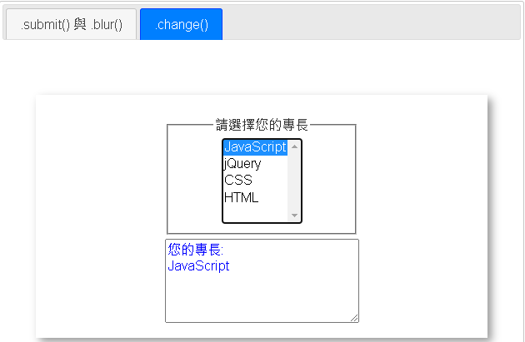

<!DOCTYPE html>

<html>

<head>

<meta charset="utf-8" />

<title>表單事件(Form Event)</title>

<link rel="icon" href="./favicon.ico" />

<style type="text/css">

(略)

#p3 fieldset {

width: 40%;

margin: 5px auto;

}

</style>

<link href="stylesheets/jquery-ui/base/jquery-ui.min.css" rel="stylesheet" />

<script src="javascripts/jquery-3.6.1.min.js"></script>

<script src="javascripts/jquery-ui.min.js"></script>

<script type="text/javascript">

$(function () {

$("#tabs").tabs();

(略)

$("#p2 #select1").change(function () {

var s = "";

$(":selected", this).each(function () {

s += $(**this**).html() + "\n";

//s += $(this).text() + "\n"; //.html() vs .text()

});

$("#p2 textarea").val(`您的專長:\n${s}`);//例如: 您的專長:JavaScript

});

});

</script>

</head>

<body>

<div id="tabs">

<ul>

<li><a href="#p1">.submit() 與 .blur()</a></li>

<li><a href="#p2">.change()</a></li>

</ul>

(略)

<div id="p2">

<div class="main-box">

<fieldset>

<legend>請選擇您的專長</legend>

<select id="select1" name="specialty" size="5" multiple> <!--若使用multiple屬性，

則size屬性的預設值為4-->

<option value="JS">JavaScript</option>

<option value="jQ">jQuery</option>

<option value="CS">CSS</option>

<option value="HTML">HTML</option>

</select>

</fieldset>

<textarea rows="5" cols="30" style="color:blue;"></textarea>

</div>

</div>

</div>

</body>

</html>

# 註冊「事件監聽器」的進階方法

## 將一個「事件監聽器」綁定至多個事件

### 常用的「事件」相關API

#### jQuery物件.on()

**.on( events [, selector ] [, data ], handler )**

* Attach an event handler function for one or more events to the selected elements.
* Parameters:
  + - events
      * Type: String
      * One or more space-separated event types , such as "click dblclick".
    - selector
      * Type: String
      * A selector string to filter the descendants(可以是未來才建立的後代元素) of the selected elements that trigger the event. If the selector is null or omitted, the event is always triggered when it reaches the selected element.
    - data
      * Type: Anything
      * Data to be passed to the handler in event.data when an event is triggered.
    - handler
      * Type: Function( Event eventObject [, Anything extraParameter ] [, ... ] )
      * A function to execute when the event is triggered.
* Returns: jQuery

### 常用的「工具函式」相關API

#### jQuery.each()

**jQuery.each(array, callback )**

* A generic iterator function, which can be used to seamlessly iterate over both objects and arrays.
* Arrays and array-like objects with a length property are iterated by numeric index, from 0 to length-1. Other objects are iterated via their named properties.
* Parameters:
  + - array
      * Type: ArrayLikeObject
      * The array or array-like object to iterate over.
    - callback
      * Type: Function( Integer indexInArray, Object value )
      * The function that will be executed on every value.
* Returns: Object

**jQuery.each( object, callback )**

* Parameters:
  + - object
      * Type: Object
      * The object to iterate over.
    - callback
      * Type: Function( String propertyName, Object valueOfProperty )
      * The function that will be executed on every value.
* Returns: Object

### 範例程式：T07.html(第一頁)

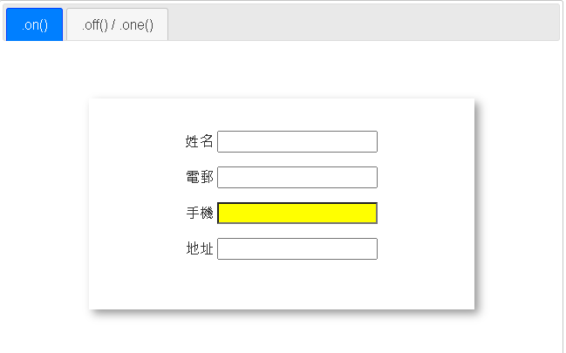

<!DOCTYPE html>

<html>

<head>

<meta charset="utf-8" />

<title>註冊「事件監聽器」進階方法</title>

<link rel="icon" href="./favicon.ico" />

<style type="text/css">

.main-box {

margin: 50px auto;

width: 400px;

height: 200px;

padding: 20px;

box-shadow: 5px 5px 10px #999;

border: 1px solid #fff;

text-align: center;

}

</style>

<link href="stylesheets/jquery-ui/base/jquery-ui.min.css" rel="stylesheet" />

<script src="javascripts/jquery-3.6.1.min.js"></script>

<script src="javascripts/jquery-ui.min.js"></script>

<script type="text/javascript">

$(function () {

$("#tabs").tabs();

//.on( events [, selector ] , handler )

// 參數selector: 指定您欲對那些後代元素(可以是未來建立的後代元素)

註冊事件處理器。(如果省略selector，則註冊的對象為原本的父元素)

$("#p1 .main-box").on("mouseenter mouseleave", ":text", function (event) {

if (event.type == "mouseenter") {//event.type :傳回事件類型(字串)

$(this).css({ 'background-color': 'yellow' });

}

else {

$(this).css({ 'background-color': '' });

}

});

var inputLabels = ['姓名', '電郵', '手機', '地址'];

//動態新增<input>元素

$.each(inputLabels, function (index, value) {

var s = `<p><label>${value} <input type="text" size="20" /></label></p>`;

$("#p1 .main-box").append(s);

});

(略)

});

</script>

</head>

<body>

<div id="tabs">

<ul>

<li><a href="#p1">.on()</a></li>

<li><a href="#p2">.off() / .one()</a></li>

</ul>

<div id="p1">

<div class="main-box"></div>

</div>

<div id="p2">

(略)

</div>

</div>

</body>

</html>

## 將一個「事件監聽器」從多個事件解綁

### 常用的「事件」相關API

#### jQuery物件.off()

**.off( events [, selector ] [, handler ] )**

* Remove an event handler.
* Parameters:
  + - events
      * Type: String
      * One or more space-separated event types , such as "click".
    - selector
      * Type: String
      * A selector which should match the one originally passed to .on() when attaching event handlers.
    - handler
      * Type: Function( Event eventObject )
      * A handler function previously attached for the event(s).
  + Returns: jQuery

### 範例程式：T07.html(第二頁)

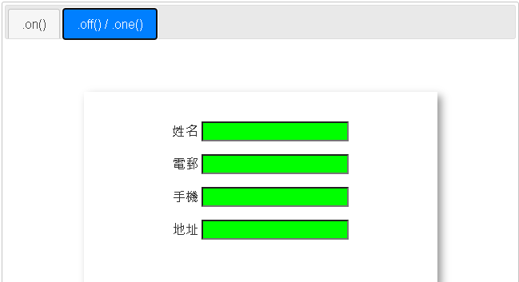

<!DOCTYPE html>

<html>

<head>

(略)

<script type="text/javascript">

$(function () {

$("#tabs").tabs();

(略)

$("#p2 :text").one("mouseenter mouseleave", function (event) {

if (event.type == "mouseenter") {//event.type :傳回事件類型(字串)

$(this).css({ 'background-color': 'lime' });

}

else {

$(this).css({ 'background-color': '' });

}

});

$("#p2 :text").off("mouseleave");//取消.on()或.one()註冊的事件處理器

});

</script>

</head>

<body>

<div id="tabs">

<ul>

<li><a href="#p1">.on()</a></li>

<li><a href="#p3">.off() / .one()</a></li>

</ul>

<div id="p1">

(略)

</div>

<div id="p2">

<div class="main-box">

<p>

<label>姓名 <input type="text" size="20" /></label>

</p>

<p>

<label>電郵 <input type="text" size="20" /></label>

</p>

<p>

<label>手機 <input type="text" size="20" /></label>

</p>

<p>

<label>地址 <input type="text" size="20" /></label>

</p>

</div>

</div>

</div>

</body>

</html>

## 將一個「事件監聽器」一次性地綁定至多個事件

### 常用的「事件」相關API

#### jQuery物件.one()

**.one( events [, data ], handler )**

* Attach a handler to an event for the elements. The handler is executed at most once per element per event type.
* Parameters:
  + - events
      * Type: String
      * A string containing one or more JavaScript event types, such as "click" or "submit," or custom event names.
    - data
      * Type: PlainObject
      * Data to be passed to the handler in event.data when an event is triggered.
    - handler
      * Type: Function( Event eventObject )
      * A function to execute at the time the event is triggered.
  + Returns: jQuery

### 範例程式：T07.html(第二頁)

(請參考7.2.2)

# jQuery UI

## jQuery UI 介紹

* jQuery UI是建構在jQuery函式庫上的一組使用者介面互動、特效、UI元件及佈景主題(user interface interactions, effects, widgets, and themes)。
* 無論您是開發高度互動的Web應用程式，還是僅僅需要在瀏覽器視窗上添加一個日期選擇器，jQuery UI 都是一個不錯的選擇。
* jQuery UI 官方網址：https://jqueryui.com/

## Datepicker

* Select a date from a popup or inline calendar.

### 使用要點

$(" input[type=text]").datepicker( {options });

* + dateFormat: 設定日期格式
    - 日期格式設定參數參考下面說明
    - 常用設定實例: 'yy/mm/dd'
  + defaultDate: 設定預設日期
    - 預設: 當日
  + numberOfMonths: 設定顯示之月數
    - 常用設定方式: [rows,cols]
  + showOn: 設定顯示之時機
    - 設定值: "focus"(預設)、"button"、"both"
  + buttonImage: 設定按鈕之圖示
    - 例如: 'images/calendar.jpg'
  + buttonText: 設定按鈕之文字
    - 若buttonImage同時設定，則本選項變成tooltip
  + changeYear: 設定年度是否可使用下拉選單點選
    - 預設: false
    - 通常搭配yearRange，以設定可點選的年度區間值
  + yearRange: 設定年度下拉選單之選項的範圍值
    - 設定方式
* "2002:2012"
* "-1:+2" (當日 前一年~後兩年)
* "c-1:c+2" (目前所點選日期之年度 前一年~後兩年)
  + - 預設: "c-10:c+10"
  + minDate: 設定可點選之最小日期
    - 預設null (即不限)
  + maxDate: 設定可點選之最大日期
    - 預設null(即不限)
  + 日期格式(dateFormat)設定參數

d - day of month (no leading zero)

dd - day of month (two digit)

o - day of the year (no leading zeros)

oo - day of the year (three digit)

D - day name short

DD - day name long

m - month of year (no leading zero)

mm - month of year (two digit)

M - month name short

MM - month name long

y - year (two digit)

yy - year (four digit)

* + 日期選擇器中文化
    - 引入: jquery.ui.datepicker-zh-TW.js 或
    - 網頁ready時執行：

$.datepicker.regional['zh-TW'] = {

closeText: '關閉',

prevText: '&#x3c;上月',

nextText: '下月&#x3e;',

currentText: '今天',

monthNames: ['一月','二月','三月','四月','五月','六月', '七月','八月','九月','十月','十一月','十二月'],

monthNamesShort: ['一','二','三','四','五','六', '七','八','九','十','十一','十二'],

dayNames: ['星期日','星期一','星期二','星期三','星期四','星期五','星期六'],

dayNamesShort: ['周日','周一','周二','周三','周四','周五','周六'],

dayNamesMin: ['日','一','二','三','四','五','六'],

weekHeader: '周',

dateFormat: 'yy/mm/dd',

firstDay: 1,

isRTL: false,

showMonthAfterYear: true,

yearSuffix: '年'};

$.datepicker.setDefaults ( $.datepicker.regional['zh-TW'] );

### 使用範例：T08.html

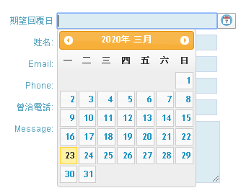

#### 樣式表

<link href="stylesheets/greefies/style.css" rel="stylesheet" />

<link href="stylesheets/jquery-ui/ui-lightness/jquery-ui.css" rel="stylesheet" />

<style type="text/css">

/* 下列覆寫datepicker原始CSS設定 */

button.ui-datepicker-trigger {padding:0px 3px; height:22px;}

</style>

#### JavaScript

<script src="javascripts/jquery-3.6.1.min.js"></script>

<script src="javascripts/jquery-ui.min.js"></script>

<script src="javascripts/jquery.ui.datepicker-zh-TW.js"></script>

<script type="text/javascript">

$(function () {

$("input[name=date]").datepicker(

{

dateFormat: 'yy/mm/dd',

showOn: "both",

buttonImage: "images/calendar.png",

buttonText:"挑選日期"

});

});

</script>

#### HTML

<div id="contact_form"">

(略)

<input style="display: inline" type="text" name="date" class="contact_input" />

(略)

</div>

## Accordion

* Convert a pair of headers and content panels into an accordion.

### 使用要點

$("#right_nav").accordion();

* + #right_nav選擇器對應之HTML元素結構：

<div>

<div>群組標題1</div>

<ul>

<li><a href="#">option1</a></li>

<li><a href="#">option2</a></li>

</ul>

<div>群組標題2</div>

<ul>

<li><a href="#">option1</a></li>

<li><a href="#">option2</a></li>

</ul>

</div>

### 使用範例：T08.html

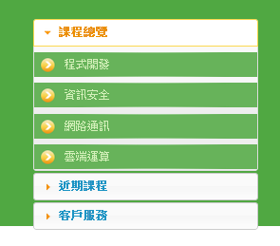

#### 樣式表

<link href="stylesheets/greefies/style.css" rel="stylesheet" />

<link href="stylesheets/jquery-ui/ui-lightness/jquery-ui.css" rel="stylesheet" />

#### JavaScript

<script src="javascripts/jquery-3.6.1.min.js"></script>

<script src="javascripts/jquery-ui.min.js"></script>

<script type="text/javascript">

$(function () {

$("#right_nav").accordion();

});

</script>

#### HTML

<div id="right_nav">

<div>課程總覽</div>

<ul>

<li><a href="#">程式開發</a></li>

<li><a href="#">資訊安全</a></li>

<li><a href="#">網路通訊</a></li>

<li><a href="#">雲端運算</a></li>

</ul>

<div>近期課程</div>

<ul>

<li><a href="#" >PHP+MySQL動態網站開發實務</a></li>

<li><a href="#">JavaScript+jQuery 動態網頁設計</a></li>

<li><a href="#">Android行動應用開發SOHO養成班</a></li>

<li><a href="#">CSS網頁精修班</a></li>

</ul>

<div>客戶服務</div>

<ul>

<li><a href="#">官方網站</a></li>

<li><a href="#">電子郵件</a></li>

<li><a href="#">行動App</a></li>

<li><a href="#">客服電話</a></li>

</ul>

</div>

## Autocomplete

* Autocomplete enables users to quickly find and select from a pre-populated list of values as they type, leveraging searching and filtering.

### 使用要點

$("input[type=text]").autocomplete( { source:[ ] } );

* + source: 設定自動完成的資料來源，例如: ["Java","JavaScript"]

### 使用範例：T08.html

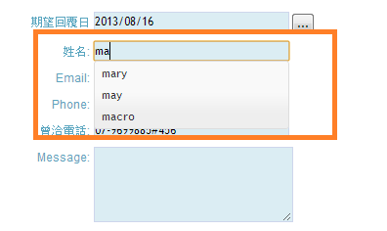

#### 樣式表

<link href="stylesheets/greefies/style.css" rel="stylesheet" />

<link href="stylesheets/jquery-ui/ui-lightness/jquery-ui.css" rel="stylesheet" />

#### JavaScript

<script src="javascripts/jquery-3.6.1.min.js"></script>

<script src="javascripts/jquery-ui.min.js"></script>

<script type="text/javascript">

$(function () {

keywords = ['hello', 'mary', 'may','michael','macro', 'hellen','pink','peter','peach' ];

$("#p1 #contact_form input[name='name']").

autocomplete({ source: keywords });

});

</script>

#### HTML

<div id="contact_form"">

(略)

<input type="text" name="name" class="contact_input" />

(略)

## Dialog

* Open content in an interactive overlay.

### 使用要點

$("div").dialog( {options} );

* + width: 設定對話框之寬度
    - 單位: pixel
    - 預設: 300
  + modal: 設定對話框是否具modal模式
    - 預設: false
  + autoOpen: 設定對話框是否自動開啟
    - 預設: true
  + title: 設定對話框標題列之標題
    - 預設: null
  + buttons: 設定對話框欲顯示之按鈕
    - 預設: []
    - 常用設定如:

[ { /* #1按鈕 */

text: '確定',

icons: { primary: "ui-icon-check" }, /*設定按鈕圖示;primary:對應按鈕左側之圖示*/

click: function () { } /*註冊click事件處理器*/

},

{ /* #2按鈕 */ (略) }

]

### 使用範例：T08.html

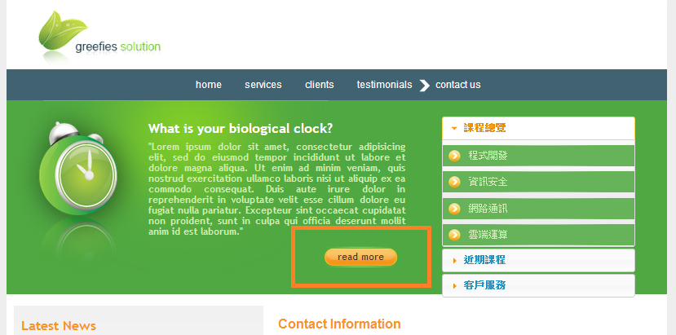

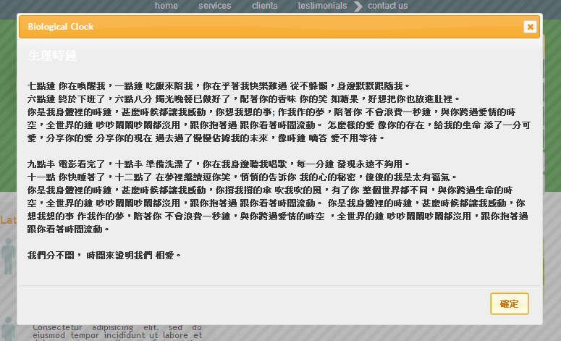

#### 樣式表

<link href="stylesheets/greefies/style.css" rel="stylesheet" />

<link href="stylesheets/jquery-ui/ui-lightness/jquery-ui.css" rel="stylesheet" />

#### JavaScript

<script src="javascripts/jquery-3.6.1.min.js"></script>

<script src="javascripts/jquery-ui.min.js"></script>

<script type="text/javascript">

$(function () {

var dialog1=$("<div></div>").load('BiologicalClock.html #div1')

.dialog(

{

width: 800,

modal: true,

autoOpen: false,

title: 'Biological Clock ',

buttons:

[{

text:'確定',

icons: { primary: "ui-icon-check" },

click:function(){ $(this).dialog('close') }

}

]

}

);

$(".green_box .read_more a").click(function () {

$(this).blur();//左式解決dialog與tooltip同時存在之問題

dialog1.dialog('open');

return false;

});

});

</script>

#### HTML

<div class="green_box">

(略)

<div class="read_more">

<a href="#" title="查看詳細內容">read more</a>

</div>

(略)

</div>

## Draggable

* Allow elements to be moved using the mouse.

### 使用要點

$(".tel").draggable({ helper: 'clone', opacity: 0.5 });

* + helper: 設定元素被拖曳的模式
    - "original"(預設)
    - "clone"
  + opacity: 設定被拖曳元素的不透明度
    - 0~1

### 使用範例：T08.html

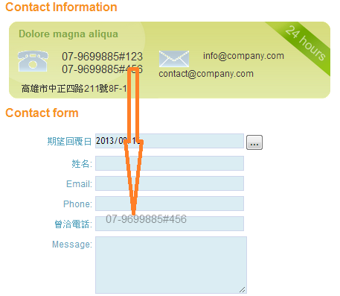

#### 樣式表

<link href="stylesheets/greefies/style.css" rel="stylesheet" />

<link href="stylesheets/jquery-ui/ui-lightness/jquery-ui.css" rel="stylesheet" />

#### JavaScript

<script src="javascripts/jquery-3.6.1.min.js"></script>

<script src="javascripts/jquery-ui.min.js"></script>

<script type="text/javascript">

$(function () {

$(".tel")**.draggable(**{ helper: 'clone', opacity: 0.5 }**);**

$("#contact_form input[name='contacted_phone']")

**.droppable(**

{

drop: function (event, ui) {

$(this).val(ui.draggable.text());

}

}

**);**

});

</script>

#### HTML

<div id="right_content"">

(略)

<span class="tel">07-9699885#123</span><br />

<span class="tel">07-9699885#456</span>

(略)

<div id="contact_form">

(略)

<div class="form_row">

<label>曾洽電話:</label>

<input type="text" name="contacted_phone" class="contact_input" />

</div>

(略)

</div>

</div>

## Droppable

* Create targets for draggable elements.

### 使用要點

$("#contact_form input[name='contacted_phone']").droppable({

drop: function (event, ui) {

$(this).val(ui.draggable.text());

}

});

* + drop: 設定drop事件處理器
    - function(event,ui){ }

### 使用範例：T08.html

(參考8.6.2)

## Tooltip

* Customizable, themeable tooltips, replacing native tooltips.

### 使用要點

$(document).tooltip( {options } );

* + items: 設定網頁中欲提供工具提示框功能之元素
    - 設定值: 選擇器字串
    - 預設值: "[title] "
  + content: 設定工具示框顯示的內容
    - 設定值: function或string
    - 預設值: function (回傳元素之title屬性值)
  + show|hide: 設定工具提示框顯示|隱藏之特效
    - 預設值: { effect: 'fadeIn|fadeOut', duration: 'normal', delay: 0, easing: 'swing' }
    - effect可設定
      * jQuery: show|hide、fadeIn|fadeOut、slideDown|slideUp
      * jQuery UI: bounce、drop、explode、fade、hightlight等 (詳細項目參考jQuery UI🡪Effects🡪Effect)

### 常用的「工具函式」相關API

#### jQuery.is()

**.is( selector )**

* Check the current matched set of elements against a selector, element, or jQuery object and return true if at least one of these elements matches the given arguments.
* Parameters:
  + - selector
      * Type: Selector
      * A string containing a selector expression to match elements against.

### 使用範例：T08.html

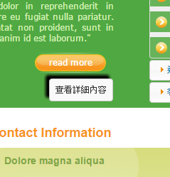

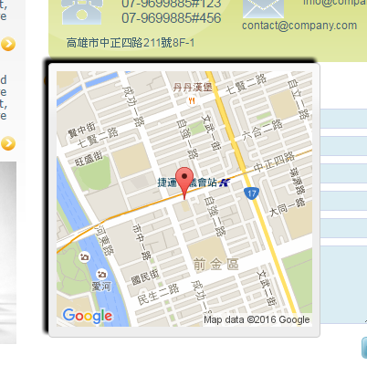

#### 樣式表

<link href="stylesheets/greefies/style.css" rel="stylesheet" />

<link href="stylesheets/jquery-ui/ui-lightness/jquery-ui.css" rel="stylesheet" />

#### JavaScript

<script src="javascripts/jquery-3.6.1.min.js"></script>

<script src="javascripts/jquery-ui.min.js"></script>

<script type="text/javascript">

$(function () {

$(document).tooltip(

{

items: "[title],[data-geo]", //預設[title]

content: function () {

var element = $(this);

if (element.is("[title]"))

return element.attr('title');

else if (element.is("[data-geo]")) {

var addr = element.text();

return "<img src='https://maps.googleapis.com/maps/api/staticmap

?zoom=15&size=280x280&maptype=roadmap

&key=[Google's API key]&markers=" +addr + "'/>";

//Google Maps Static API

}

},

show: { effect: 'fadeIn', duration: 'normal', delay: 0, easing: 'swing' },//左列為特效預設值

hide: { effect: 'explode', delay: 250 }

});

</script>

#### HTML

<div id="contact_form"">

(略)

<a href="#" title="查看詳細內容">read more</a>

(略)

<div class="adress" data-geo="" style="width: 200px;">

高雄市中正四路211號8F-1

</div>

(略)

</div>

|  |
| --- |
| **申請Google's「API金鑰」的步驟**   1. 登入Google Cloud Platform (https://cloud.google.com/ ) 2. 在「導覽選單」點選「API和服務」    1. 點選「憑證」 > 建立憑證 > API金鑰    2. 點選「資訊主頁」 > 啟用API和服務 > Maps Static API       * 每日免費: 25,000次請求       * 超額者: US$ 0.5/1,000次請求       * 每天要求上限: 100,000 次 |

## Spinner

* Enhance a text input for entering numeric values, with up/down buttons and arrow key handling.

### 使用要點

$(input).spinner( {options } );

* + max: 設定可允許的最大值
    - 預設值: null (即不限)
  + min: 設定可允許的最小值
    - 預設值: null (即不限)
  + page: 設定按下pageUp/pageDown按鍵一次所增加/減少之數值
    - 預設值: 10
  + step: 設定點擊按鈕一次所增加/減少之數值
    - 預設值: 1

### 使用範例：T08.html

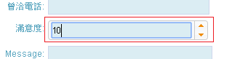

#### 樣式表

<link href="stylesheets/greefies/style.css" rel="stylesheet" />

<link href="stylesheets/jquery-ui/ui-lightness/jquery-ui.css" rel="stylesheet" />

#### JavaScript

<script src="javascripts/jquery-3.6.1.min.js"></script>

<script src="javascripts/jquery-ui.min.js"></script>

<script type="text/javascript">

$(function () {

$("input[name=sat_degree]").spinner({

max: 10, min: 1

});

});

</script>

#### HTML

<div id="contact_form">

(略)

<div class="form_row">

<label>滿意度:</label><input type="text" name="sat_degree"

class="contact_input" style="height:14px;width:190px" />

</div>

(略)

## Tabs

* A single content area with multiple panels, each associated with a header in a list.

### 使用要點

$("div").tabs( );

### 使用範例：T01.html

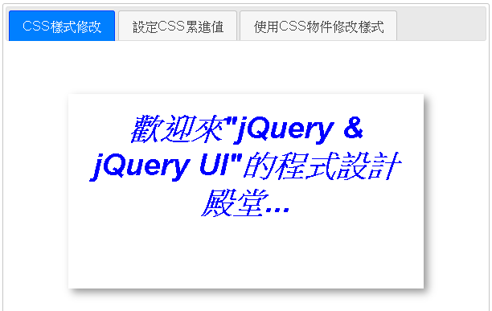

#### 樣式表

<link href="stylesheets/jquery-ui/ui-lightness/jquery-ui.css" rel="stylesheet" />

#### JavaScript

<script src="javascripts/jquery-3.6.1.min.js"></script>

<script src="javascripts/jquery-ui.min.js"></script>

<script type="text/javascript">

$(function () {

$("#tabs").tabs();

})

</script>

#### HTML

<div id="tabs">

<ul>

<li><a href="#p1">CSS樣式修改</a></li>

<li><a href="#p2">設定CSS累進值</a></li>

<li><a href="#p3">使用CSS物件修改樣式</a></li>

</ul>

<div id="p1"> (略) </div>

<div id="p2"> (略) </div>

<div id="p3">(略) </div>

</div>